**Stamford University Bangladesh**

**Department of Computer Science & Engineering**



**Group name: Bit Legion**

**Online Shopping System**

**Software Engineering Sessional**

**CSI 332**

**Proposal**

**Submitted by:**

**Shekh Raisul Islam ID:CSE06307450**

**Tanjina Sharmin ID:CSE06307439**

**Md Juwel Islam ID:CSE06307460**

**Introduction:**

Online shopping is the process whereby consumers directly buy goods or services from a seller in real-time, without an intermediary service, over the Internet. It is a form of electronic commerce. This project is an attempt to provide the advantages of online shopping to customers of a real shop. It helps buying the products in the shop anywhere through internet by using an android device. Thus the customer will get the service of online shopping and home delivery from his favorite shop.

**Goals:**

* To develop an easy to use web based interface where users can search for products , view a complete description of the products and order the products.
* The user can easily add a product to or remove a product from the shopping cart.
* An user can view the complete specification of the product along with various images and they can also write their own reviews.
* An admin can view the review or feedback of the user along with other details.

**Scope of Work**

**Page Templates**

* Design Templates ( No Cap on the number of revisions)
* User Visibility research and Layout Engineering
* Logos ( No Cap on the number of revisions)

**Template Layout**

**Banner**

•Size according to specifications

• Logo Placement

• Text

• Graphics

**User Visibility Content**

• Information bar

• Menu Bar

• Tool bar

• Side Bar

• Header and Footer

• Text and Graphics

**Design Specifications**

Design tools and technologies. The design and layout of the application will be SEO friendly constructed using CSS and XHTML, DHTML along with use of AJAX and keeping in mind the latest web 2.0 trends. The application upon completion will be integrated with Google analytics for keeping an eye on the statistics of the site. It will carry tell a friend and printer friendly version at all pages. To help peoplebookmark the site easily; add this widget will be embedded at the top of the homepage.

**Front End**

**The front end will have following features:-**

* Header Pages
* Footer Pages
* Website Content Page
* Customer Registration
* Existing Customer
* Function of Customers
* My Account Control Panel for Customers
* Search
* Advanced Search
* Products
* Products Catalog
* Products Information
* Customize
* Events
* Review
* Shopping Cart
* Check out
* Shipping
* Payment Gateway
* Social Media Integration
* Newsletter
* Contact Us
* FAQ

**Administrative Panel**

* Customers Management
* Product Management
* General Management
* Order Management
* Content Management
* Reports Management

**Delivery Schedule**

|  |  |
| --- | --- |
| weeks | Key Deliverables (Modules) |
| 2 | System Analysis . |
| 3 | Knowledge transfer, Working on the layout, Working on the functional requirements, Locking in the database design, Workings on Specific requirements and project review. |
| 2 | Development of module for customer’s registration, my account panel, search, advanced search with corresponding admin panel. |
| 2 | Development of module for products information, products catalogue, Customize, Events, shopping cart, and check out with corresponding admin panel. |
| 2 | Development of module for payment gateway integration, shipping gateway integration, reviews and with corresponding admin panel. |
| 2 | Development of module for social media integration, newsletter, static pages and contact us page with corresponding admin panel. |
| 5 | Exhaustive testing, Ensuring Browser compatibility, Final delivery. |

**Process Flow**

**Analysis**

**Design**

**Review**

**Implement**

**Testing**

**Project Delivery**

Our Methodology… Best quality with the best design

**Support**

**Gantt Chart:**

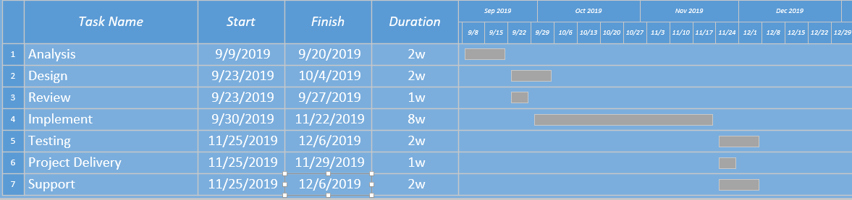

**Feasibilities:**

**Technical Feasibility:**

* Technology exists to develop a system.
* The proposed system is capable of proving adequate response and regardless of the number of users.
* The proposed system being modular to the administrator, if he/she wants can add more features in the future and as well as be able to expand the system.
* As far as the hardware and software is concerned, the proposed system is completely liable with proper backup and security.

**Operational Feasibility:**

* The proposed system will improve the total performance.
* Customers here are the most important part of the system and the proposed system will provide them with a convenient mode of operation for them.
* The proposed system will be available of the customers throughout the globe.
* The proposed system will provide a better market for different dealers.

**Economical Feasibility:**

* The cost of hardware and software is affordable.
* High increase of the amount of profit earned by going global.
* Easy and cheap maintenance of the system possible.
* Very cheap price for going global.

**Risks and Threats**

All this might make it sound as if your e-commerce business can’t possibly fail. Some risks are particularly relevant to e-commerce companies, such as:

1. Hacking
2. Credit card scams
3. Hardware failures
4. Unreliable shipping services
5. Software errors
6. Changing laws

**Conclusion:**

Online shopping is the process whereby consumers directly buy goods or services from a seller in real-time, without an intermediary service, over the Internet. It is a form of electronic commerce. An online shop, e-shop, e-store, internet shop, web-shop, web-store, online store, or virtual store evokes the physical analogy of buying products or services at a bricks-and-mortar retailer or in a shopping centre. The process is called Business-to-Consumer online shopping. When a business buys from another business it is called Business-to-Business online shopping.